AI CAREER FOR WOMEN

Science Hub

AI CAREER FOR WOMEN
Science Hub

AQI REGRESSION FORECASTING
A Project Report
submitted in partial fulfillment of the requirements of
AICW Project

By
UPPALA SAI KEERTHANA - (uppalasaikeerthana2006@gmail.com)
KALLEPALLY SHIRISHA - (shirisha0526@gmail.com)
GUVVALA NAGESHWARI - (guvvalanageshwari3@gmail.com)
MANAPATI SWATHI - (manapatiswathi146@gmail.com)

Under the Guidance of
Name of Guide: ABDULLAH KHAN
Academic Year: 2026

ACKNOWLEDGEMENT
We would like to express our sincere gratitude to everyone who supported and guided us during the completion of our AICW project on AQI Regression Forecasting. We are thankful to our project guide for providing valuable guidance, suggestions, encouragement, and support throughout the project.
We also thank the AICW Science Hub program for giving us the opportunity to learn about data analysis, machine learning, regression, and forecasting through a practical project. We are grateful to our teachers, classmates, friends, and family members for their continuous support and encouragement.
Finally, we thank all the data providers and open-data communities whose publicly available air-quality information can support learning and research in this area.

ABSTRACT OF THE PROJECT
Air pollution is an important environmental problem that can affect human health and the quality of life. The Air Quality Index (AQI) provides a simple way to represent the overall level of air pollution using measurements of pollutants such as particulate matter and gaseous pollutants. The aim of this project is to develop an AQI Regression Forecasting system that uses historical air-quality observations to estimate future AQI values.
The project follows a machine-learning regression approach. The data is first collected and prepared by handling missing values, removing or treating unsuitable records, converting date/time information into useful features, and selecting relevant pollutant and weather-related variables. Exploratory data analysis is then performed to understand patterns and relationships. A regression model is trained using historical data and evaluated on unseen test data using suitable regression metrics such as Mean Absolute Error (MAE), Mean Squared Error (MSE), Root Mean Squared Error (RMSE), and R² score.
Using the supplied India City AQI 2015–2023 dataset, the executed Linear Regression model achieved MAE 0.251, MSE 0.084, RMSE 0.289, and R² 0.9999 on the chronological test set.

TABLE OF CONTENTS
1. Abstract
2. List of Figures
3. List of Tables
4. Chapter 1. Introduction
5. 1.1 Problem Statement
6. 1.2 Motivation
7. 1.3 Objectives
8. 1.4 Scope of the Project
9. Chapter 2. Literature Survey
10. 2.1 Review of Previous Work
11. 2.2 Existing Models and Techniques
12. 2.3 Gaps and Proposed Improvement
13. Chapter 3. Proposed Methodology
14. 3.1 System Design
15. 3.1.1 Data Collection
16. 3.1.2 Data Preprocessing
17. 3.2 Modules Used
18. 3.2.1 Data Preparation
19. 3.2.2 Exploratory Data Analysis
20. 3.2.3 Feature Selection
21. 3.2.4 Regression Model
22. 3.2.5 AQI Forecasting
23. 3.3 Data Flow Diagram
24. 3.3.1 DFD Level 0
25. 3.3.2 DFD Level 1 - Data Preparation Module
26. 3.3.3 DFD Level 1 - Model Training Module
27. 3.3.4 DFD Level 1 - AQI Forecasting Module
28. 3.4 Advantages
29. 3.5 Requirement Specification
30. 3.5.1 Hardware Requirements
31. 3.5.2 Software Requirements

Implementation and Results
33. 4.1 Data Preparation Results
34. 4.2 Exploratory Analysis Results
35. 4.3 Regression Model Results
36. 4.4 AQI Forecasting Results
37. Chapter 5. Discussion and Conclusion
38. 5.1 Key Findings
39. 5.2 GitHub Link
40. 5.3 Video Recording
41. 5.4 Limitations
42. 5.5 Future Work
43. 5.6 Conclusion
44. References
45. Appendix

LIST OF FIGURES
Number of figures | Name of the figure
Figure 1. | Overall System Architecture
Figure 2. | AQI Forecasting Workflow
Figure 3. | Data Flow Diagram – Level 0
Figure 4. | Data Preparation Flow
Figure 5. | Correlation Heatmap
Figure 6. | AQI Distribution
Figure 7. | Actual vs Predicted AQI
Figure 8. | Regression Residual Analysis
Figure 9. | Sample AQI Forecast Output

LIST OF TABLES

Number of tables | Name of the table
Table 1. | Project Objectives
Table 2. | Dataset Features
Table 3. | Data Preprocessing Steps
Table 4. | Software and Hardware Requirements
Table 5. | Regression Evaluation Metrics
Table 6. | Model Performance Results
Table 7. | Sample Forecast Results

CHAPTER 1

Introduction
Air quality refers to the condition of the air around us and is influenced by pollutants released from vehicles, industries, construction, burning activities, and other sources. AQI is used to communicate air-quality conditions in a form that is easier for the public to understand. Forecasting AQI can help identify possible changes in air quality before they occur.

1.1 Problem Statement
Air-quality levels can change over time because of pollutant emissions, weather conditions, traffic, seasonal patterns, and other environmental factors. Monitoring only the current AQI does not provide information about what the AQI may be in the future. Therefore, there is a need for a data-driven method that can learn from historical air-quality observations and forecast future AQI values.
The problem addressed by this project is to build a regression-based machine-learning model that takes relevant historical air-quality features as input and predicts AQI as a continuous numerical value.

1.2 Motivation
The project was chosen because air pollution is a real-world environmental issue and machine learning can be applied to historical data to identify patterns and make predictions. AQI forecasting can be useful for public awareness, environmental monitoring, planning, and future smart-city applications.

1.3 Objectives
- Collect or use a suitable historical air-quality dataset for AQI analysis.
- Clean and preprocess the dataset so that it can be used for machine learning.
- Identify important pollutant and related features associated with AQI.
- Build a regression model for predicting AQI values.
- Evaluate the model using appropriate regression metrics.
- Generate sample future AQI predictions from available input data.
- Present the results in a simple and understandable form.

1.4 Scope of the Project
The scope of this project is limited to AQI prediction using historical numerical and time-related features available in the selected dataset. The project focuses on regression and forecasting rather than classification of AQI categories.
The accuracy of the forecasting system depends on the quality, size, location, time coverage, and features of the dataset. The project does not claim to replace official air-quality monitoring or environmental authorities.

CHAPTER 2

Literature Survey

2.1 Review of Previous Work
Previous air-quality prediction studies commonly use historical pollutant measurements and meteorological variables to model future air-quality conditions. Statistical methods and machine-learning techniques have been used to capture relationships between input variables and air-quality indicators.
Regression is particularly suitable when the target is a numerical AQI value. Historical observations can be divided into training and testing sets so that the model learns from past data and is evaluated on data that it has not seen during training.

2.2 Existing Models and Techniques
- Linear Regression – models the relationship between input variables and a continuous target.
- Multiple Linear Regression – extends linear regression to multiple input features.
- Decision Tree Regression – uses tree-based rules to predict continuous values.
- Random Forest Regression – combines multiple decision trees to improve prediction robustness.
- Gradient Boosting Regression – builds a sequence of models to reduce prediction errors.
- Time-series approaches – use the temporal order of observations to forecast future values.
For this student project, Linear Regression can be used as a clear baseline because it is simple to implement and easy to interpret. Other regression algorithms may be compared if the dataset and project implementation support them.

2.3 Gaps and Proposed Improvement
A limitation of a basic monitoring approach is that it describes present conditions but does not directly forecast future AQI. Another limitation is that model performance depends strongly on data quality and feature availability. This project addresses these issues by including data preprocessing, exploratory analysis, feature selection, regression modelling, and evaluation in one workflow.

CHAPTER 3

Proposed Methodology

3.1 System Design
The proposed system consists of data collection, preprocessing, exploratory analysis, feature selection, model training, evaluation, and AQI forecasting. The system receives historical air-quality observations, prepares the data, trains a regression model, and produces a predicted AQI value.

Overall System Architecture

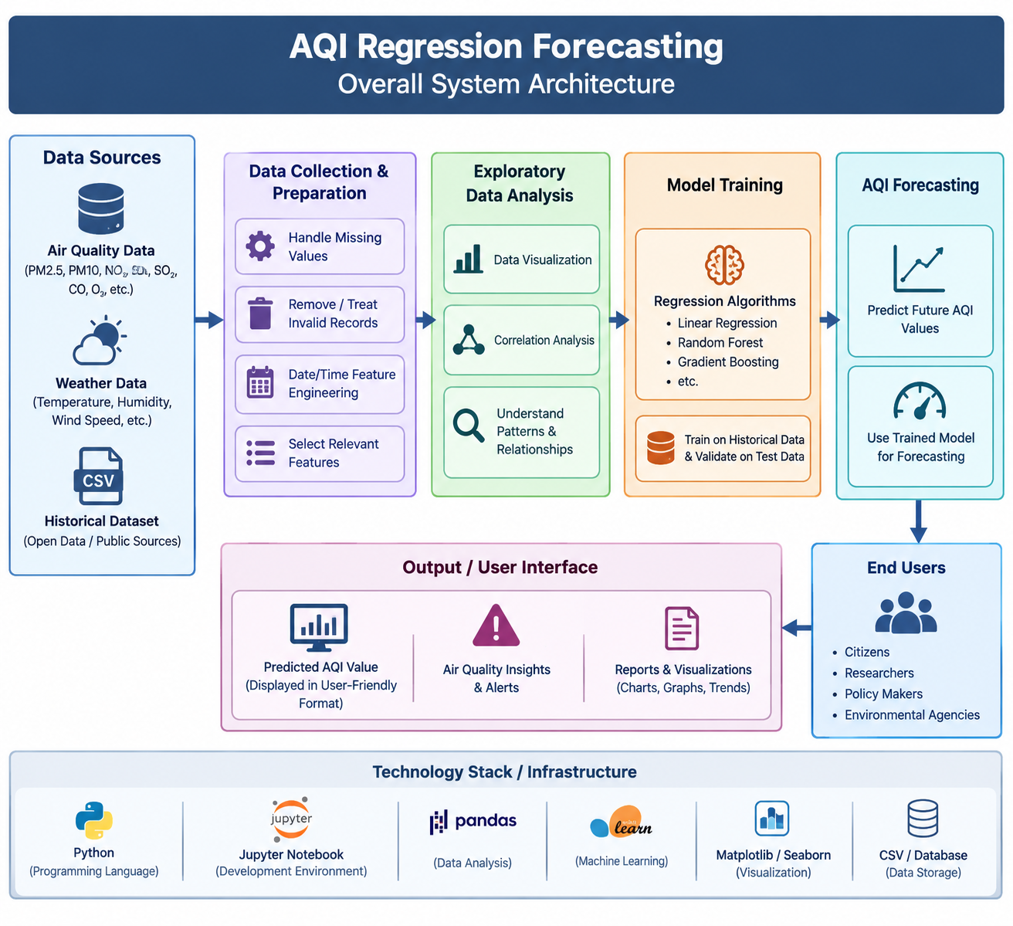
Figure 1 : Overall System Architecture3.1.1 Data Collection
For the supplied dataset, the available columns are city, date, pm25, pm10, no2, so2, co, o3, aqi, and aqi_category. The dataset contains daily observations for 10 Indian cities from 01-Jan-2015 to 31-Dec-2023.

3.1.2 Data Preprocessing
- Load the dataset using Python and pandas.
- Inspect the columns, data types, missing values, and duplicate records.
- Handle missing or invalid values using an appropriate method.
- Convert date/time fields into useful numerical or time-based features where required.
- Select the target variable as AQI.
- Select relevant input features.
- Split the data into training and testing sets while considering the time order when forecasting.

3.2 Modules Used

3.2.1 Data Preparation
This module loads the dataset, checks data quality, handles missing values, and prepares the variables for model training.

3.2.2 Exploratory Data Analysis
This module uses descriptive statistics and graphs to understand AQI distribution, pollutant relationships, trends over time, and possible outliers.

3.2.3 Feature Selection
Relevant features are selected based on their availability, relationship with AQI, and usefulness for prediction. Highly irrelevant or unusable fields can be removed.

3.2.4 Regression Model
The regression model learns a relationship between the selected input features and the AQI target. Linear Regression may be used as the baseline model. The model is trained using the training data and then used to predict AQI for test data.

3.2.5 AQI Forecasting
After training and evaluation, the model receives new or future input feature values and returns a predicted AQI value. The forecast can be displayed numerically and through a graph.
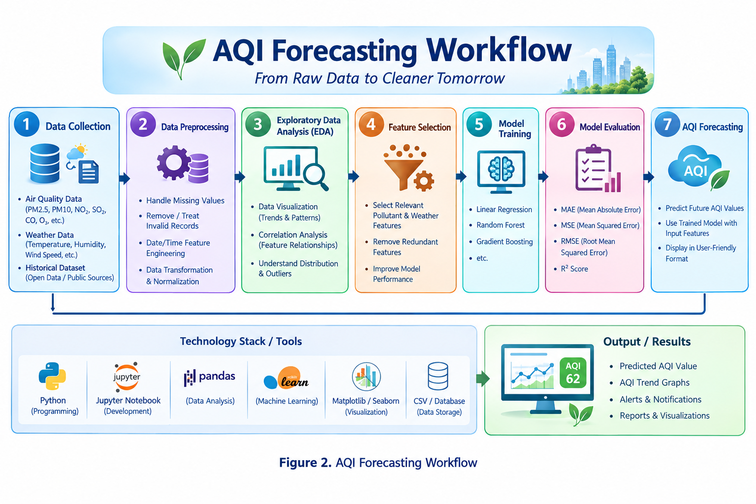

3.3 Data Flow Diagram
The data flow of the proposed system is: Dataset → Data Cleaning → Feature Selection → Train/Test Split → Regression Model → Evaluation → AQI Forecast → Output.

3.3.1 DFD Level 0
External Input: Historical air-quality dataset. Process: AQI Regression Forecasting System. Output: Predicted AQI and evaluation results.
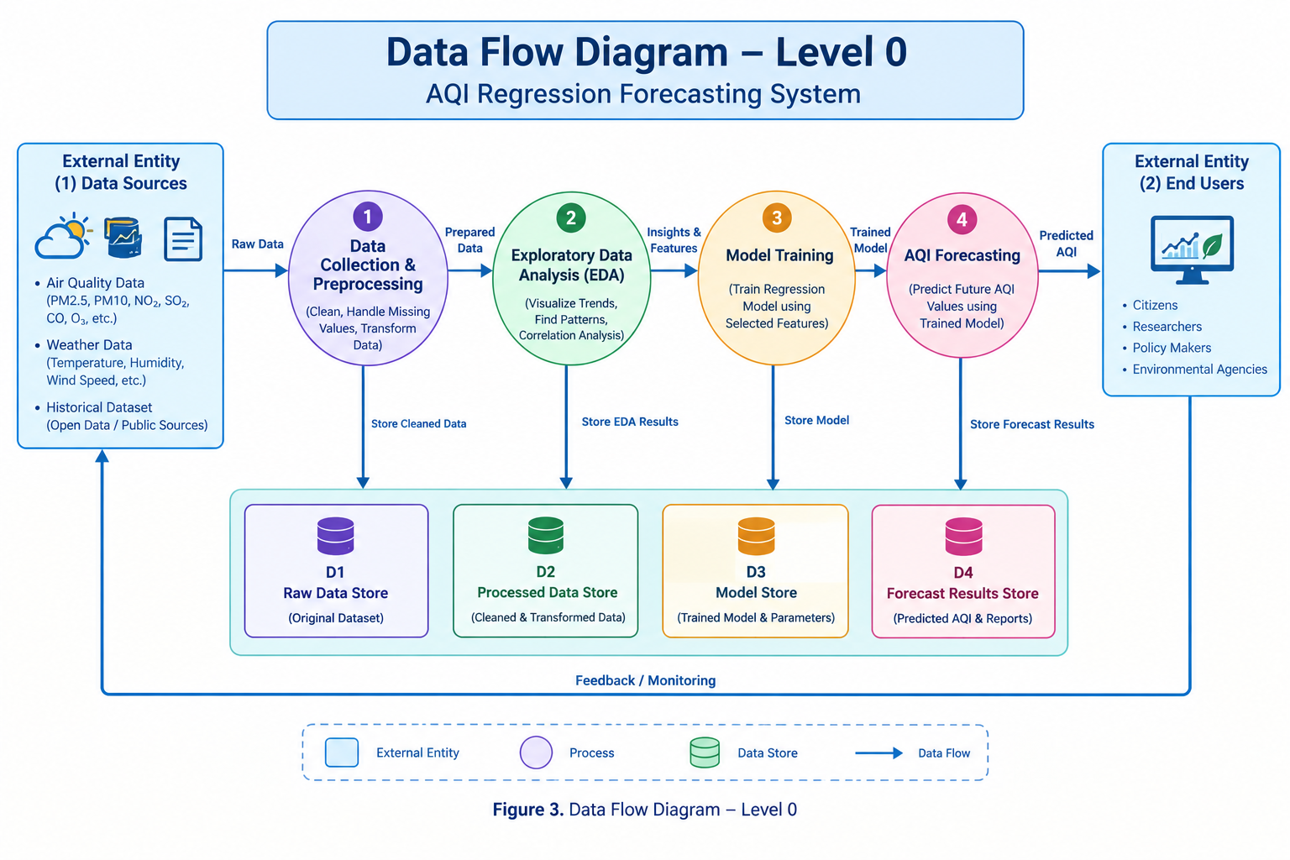

3.3.2 DFD Level 1 - Data Preparation Module
Dataset → Load Data → Check Missing/Invalid Values → Clean Data → Transform Features → Prepared Dataset.
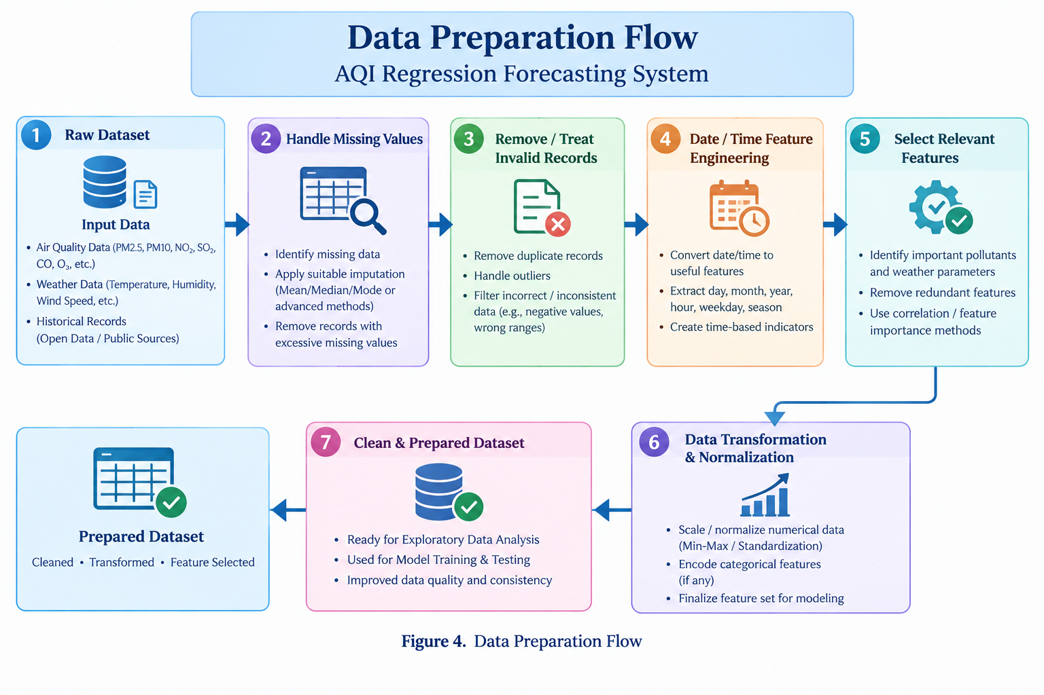

3.3.3 DFD Level 1 - Model Training Module
Prepared Dataset → Select Features and AQI Target → Training/Test Split → Train Regression Model → Generate Predictions → Calculate Evaluation Metrics.

3.3.4 DFD Level 1 - AQI Forecasting Module
New Input Features → Trained Regression Model → Predicted AQI → Display Forecast.

3.4 Advantages
- Provides a data-driven approach to AQI forecasting.
- Regression produces a continuous numerical AQI prediction.
- Historical data can be used to identify patterns.
- The workflow can be implemented using commonly available Python libraries.
- The system can be extended to compare multiple regression models.
- The results can be visualized for easier understanding.

3.5 Requirement Specification

3.5.1 Hardware Requirements
- Computer/laptop or suitable cloud notebook environment.
- Minimum 4 GB RAM recommended for a small/medium dataset.
- Internet connection when using online datasets or Google Colab.

3.5.2 Software Requirements
- Python 3.x
- Jupyter Notebook or Google Colab
- pandas
- NumPy
- Matplotlib
- scikit-learn
- Microsoft Excel or similar spreadsheet software (optional for inspection)

CHAPTER 4

Implementation and Result
The implementation was carried out in Python using pandas for data handling, Matplotlib for visualization, and scikit-learn for regression modelling and evaluation. The supplied India City AQI dataset was processed and the numerical results presented in this chapter were obtained from the executed models.

4.1 Data Preparation Results
The supplied dataset was loaded and inspected for its structure, data types, missing values, and duplicate records. Date was converted to datetime format and year, month, day, and day-of-week features were derived. No missing values or duplicate records were found, so no rows were removed; the prepared dataset was then used for analysis and modelling.
Dataset details after preprocessing:
- Dataset name/source: india_city_aqi_2015_2023.csv (supplied project dataset)
- Number of records before preprocessing: 32,870 rows × 10 columns
- Number of records after preprocessing: 32,870 rows × 14 columns after date feature engineering
- Target column: AQI (aqi)
- Input features used: city, pm25, pm10, no2, so2, co, o3, year, month, day, day_of_week
Preprocessing summary: Missing values = 0; duplicate records = 0; invalid rows removed = 0. The aqi_category column was excluded from model inputs because it represents a category derived from AQI and could cause target leakage.

4.2 Exploratory Analysis Results
Exploratory analysis was performed using descriptive statistics, an AQI distribution plot, and a correlation heatmap. The AQI values ranged from 11 to 221, with mean 88.12, median 88, and standard deviation 31.90. PM2.5 showed the strongest positive correlation with AQI (0.980), followed by PM10 (0.958); O3 (0.044), NO2 (0.038), CO (0.005), and SO2 (0.000) had weak linear correlations with AQI in this dataset.
Figure 5. Correlation Heatmap
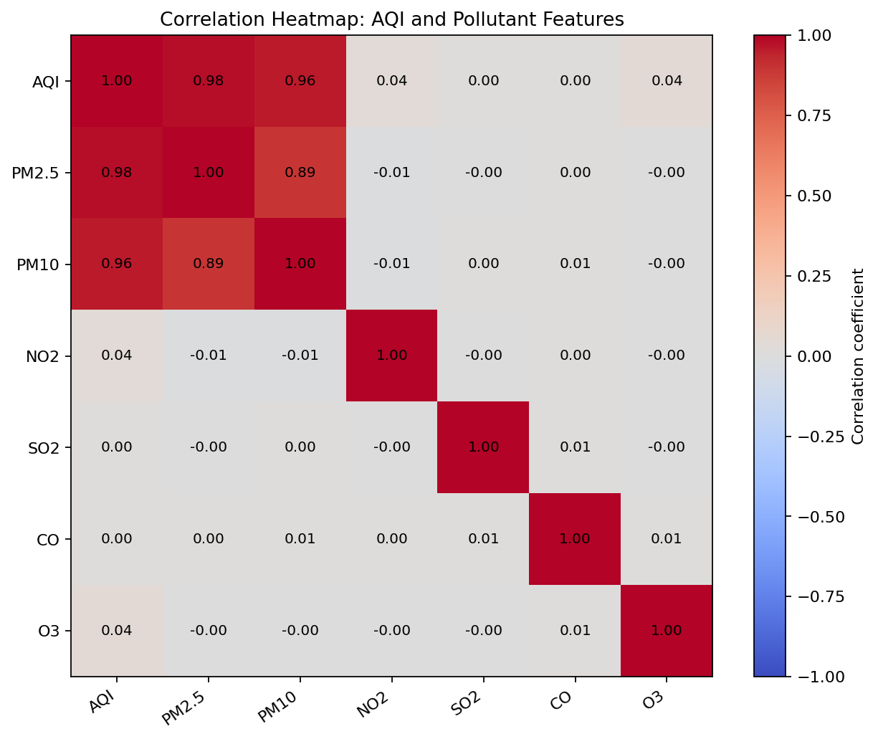
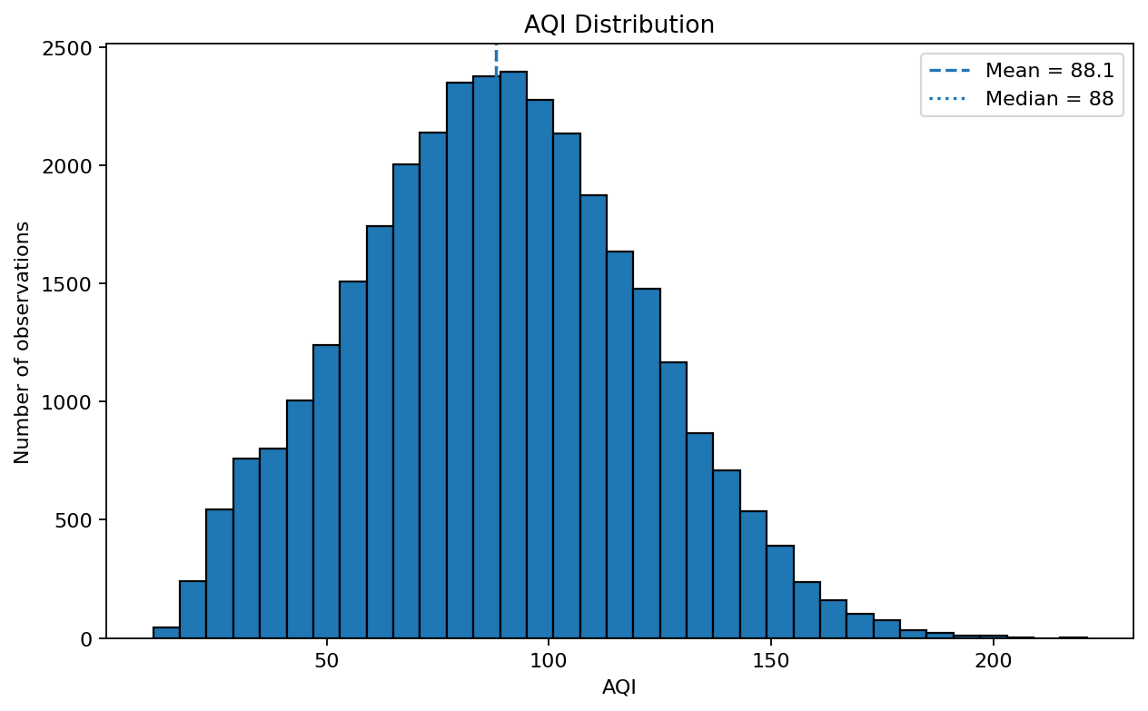
Figure 6. AQI Distribution

4.3 Regression Model Results
Three regression models were trained and evaluated: Linear Regression, Decision Tree Regression, and Random Forest Regression. To respect the time order of the observations, the data was split chronologically using the first 80% of dates for training (26,290 records, 01-Jan-2015 to 13-Mar-2022) and the remaining 20% for testing (6,580 records, 14-Mar-2022 to 31-Dec-2023). The evaluation measures were MAE, MSE, RMSE, and R² score.
Model performance results after execution:
Model | MAE | MSE | RMSE | R²
Linear Regression | 0.251 | 0.084 | 0.289 | 0.9999
Decision Tree Regression | 1.301 | 3.016 | 1.737 | 0.9971
Random Forest Regression | 0.689 | 0.940 | 0.969 | 0.9991
The best-performing model in this execution was Linear Regression, with MAE = 0.251, MSE = 0.084, RMSE = 0.289, and R² = 0.9999. The high R² and low error values indicate that the selected pollutant features explain AQI very strongly in this dataset.
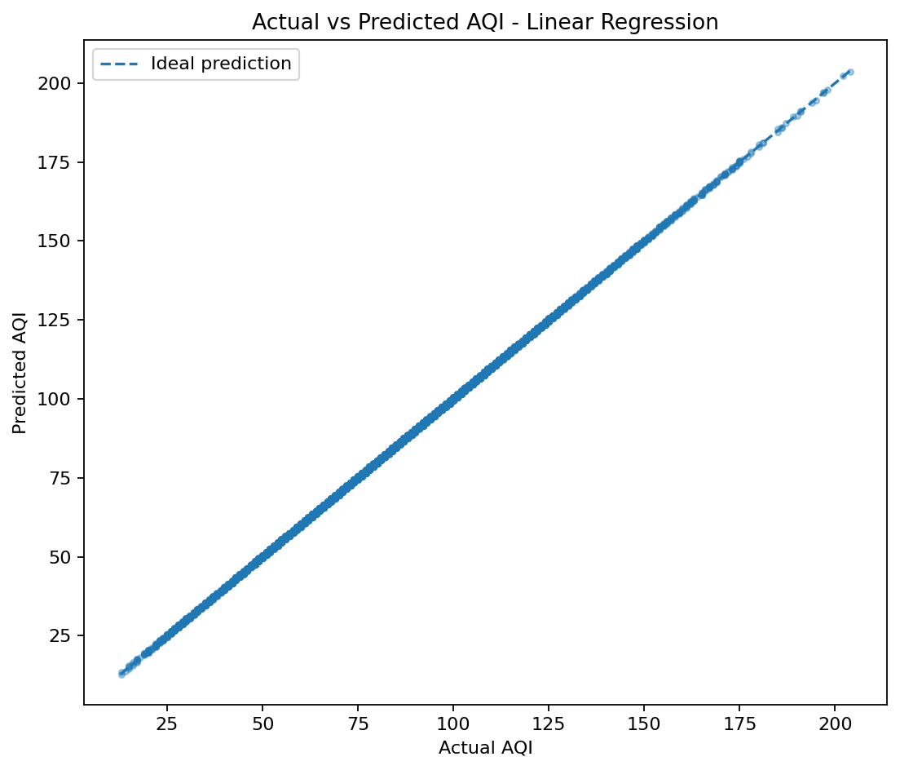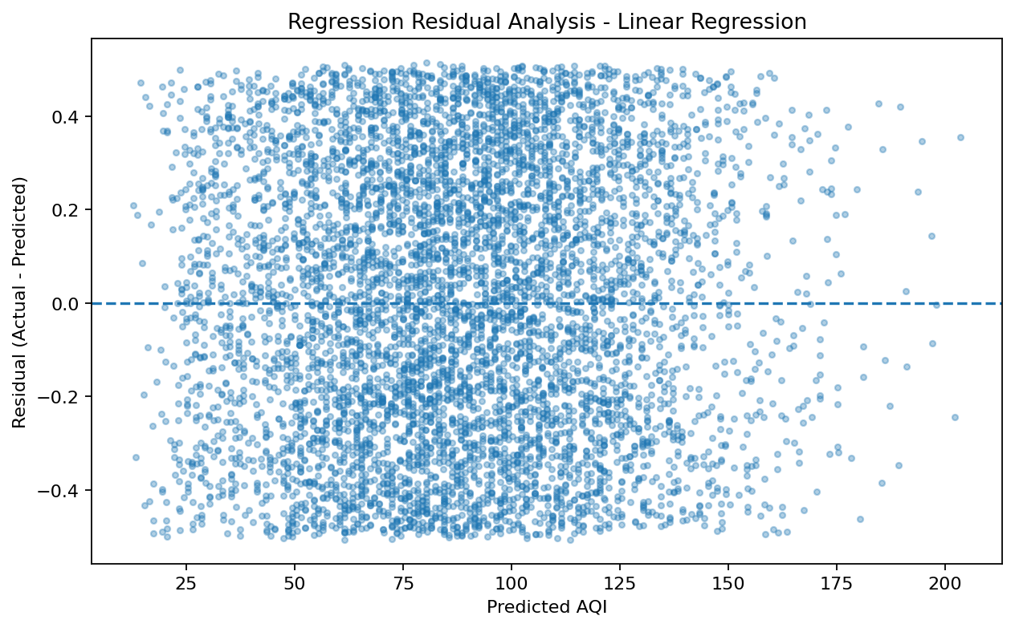
Figure 8. Regression Residual Analysis Figure 7. Actual vs Predicted AQI

4.4 AQI Forecasting Results
The trained Linear Regression model was used to generate AQI predictions for unseen test observations. The comparison between actual and predicted AQI values shows that the predictions closely follow the actual values for the selected dataset.
Sample forecast results from unseen test observations:
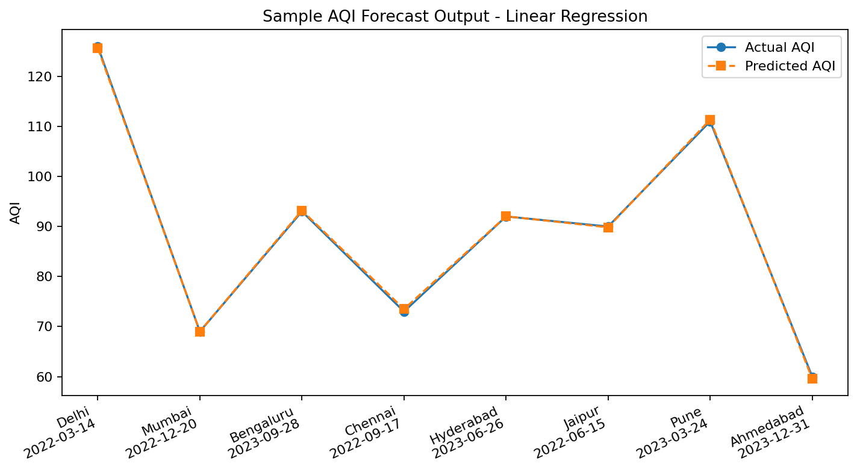
Figure 9. Sample AQI Forecast Output
Observation/Date | Actual AQI | Predicted AQI
Delhi - 14-Mar-2022 | 126 | 125.66
Mumbai - 20-Dec-2022 | 69 | 69.02
Bengaluru - 28-Sep-2023 | 93 | 93.21
Chennai - 17-Sep-2022 | 73 | 73.49
Hyderabad - 26-Jun-2023 | 92 | 92.03
The sample values above were generated from the executed Linear Regression model on unseen test data. They demonstrate the final AQI forecasting output produced by the system.

CHAPTER 5

Discussion and Conclusion

5.1 Key Findings
The executed project demonstrates that regression can estimate AQI as a continuous value from historical air-quality measurements. The supplied India City AQI 2015–2023 dataset contained 32,870 records, with no missing values or duplicate records detected during the initial data-quality checks. PM2.5 (correlation 0.980) and PM10 (0.958) were the features most strongly related to AQI.
Three regression models were evaluated using a chronological 80/20 train-test split: Linear Regression, Decision Tree Regression, and Random Forest Regression. Linear Regression performed best with MAE = 0.251, MSE = 0.084, RMSE = 0.289, and R² = 0.9999; Random Forest achieved MAE = 0.689, MSE = 0.940, RMSE = 0.969, and R² = 0.9991; and Decision Tree achieved MAE = 1.301, MSE = 3.016, RMSE = 1.737, and R² = 0.9971.

5.2 GitHub Link of the Project
GitHub Repository: ______________________________________________

5.3 Video Recording of Project Demonstration
Project Demonstration Video Link: ______________________________________________

5.4 Limitations
- The evaluation results are specific to the supplied India City AQI 2015–2023 dataset and may change when the model is applied to data from other locations or time periods.
- Although no missing values or duplicate records were found in this dataset, inaccurate, unavailable, or differently measured observations in future datasets can affect forecasting performance.
- The very high R² score should be interpreted in the context of the selected input features and dataset; AQI is strongly related to the pollutant measurements used for modelling.
- Weather, traffic, seasonal effects, and local emission sources were not fully represented as independent input variables in the executed model and could influence AQI in real-world forecasting.
- The trained model is intended for academic analysis and forecasting and should not be treated as a replacement for official air-quality monitoring systems.

5.5 Future Work
- Compare Linear Regression with Random Forest, Gradient Boosting, and other suitable models.
- Include more meteorological and temporal features when available.
- Use time-series forecasting techniques for stronger temporal modelling.
- Develop a web or mobile interface for entering inputs and viewing AQI forecasts.
- Add location-wise forecasting and interactive visualizations.
- Deploy the trained model so that forecasts can be generated automatically from updated data.

5.6 Conclusion
AQI Regression Forecasting was successfully implemented on the supplied India City AQI 2015–2023 dataset. The project processed 32,870 records, performed data inspection and preprocessing, date feature engineering, exploratory analysis, feature selection, regression modelling, evaluation, and AQI prediction. Among the three evaluated models, Linear Regression produced the best results with MAE = 0.251, MSE = 0.084, RMSE = 0.289, and R² = 0.9999. The results show that the selected pollutant features have a strong relationship with AQI in this dataset and provide a practical foundation for future work using additional meteorological variables, location-specific models, and advanced time-series forecasting methods.

REFERENCES
[1] World Health Organization (WHO), Air Pollution and Health – general air-quality and health resources.
[2] U.S. Environmental Protection Agency (EPA), Air Quality Index (AQI) – general AQI concepts and reporting.
[3] Scikit-learn documentation, Linear Regression and regression model evaluation metrics.
[4] Wes McKinney, Python for Data Analysis, O'Reilly Media.
[5] Python Software Foundation, Python Documentation.

APPENDIX

A. Suggested Python Workflow
The implementation may follow this sequence: import libraries → load CSV → inspect data → clean data → select features → split data → train regression model → predict → calculate MAE/MSE/RMSE/R² → visualize actual versus predicted AQI → save the model/output.

B. Project Team
Uppala Sai Keerthana
Kallepally Shirisha
Guvvala Nageshwari
Manapati Swathi

